**A MINI PROJECT REPORT**

**On**

**Water Quality Monitoring and Forecasting System**

*Submitted by*

|  |  |
| --- | --- |
| BAIRAGONI VAISHANAVI | 22J41A1207 |
| MALOTH THARUN | 22J41A1236 |
| POTHUGANTI NIKHIL | 23J45A01206 |
| CHANDUPATLA SIDDHARTHA | 22J41A1213 |

*in partial fulfilment of the requirementsfor the award of the degree*

*of*

**BACHELOR OF TECHNOLOGY**

in

**INFORMATION TECHNOLOGY**

Under the Guidance of

**Dr. DEENA BABU MANDRU**

Professor and HOD



**DEPARTMENT OF INFORMATION TECHNOLOGY**

**MALLA REDDY ENGINEERING COLLEGE**

(An UGC Autonomous Institution, Approved by AICTE, New Delhi&Affiliated to JNTUH, Hyderabad Maisammaguda, Secunderabad, Telangana, India 500100)

**APRIL 2025**

**MALLA REDDY ENGINEERING COLLEGE**

Maisammaguda, Secunderabad, Telangana, India 500100



**BONAFIDE CERTIFICATE**

This is to certify that the project work entitled “**Water Quality Monitoring and Forecasting System**”, submitted by BAIRAGONI VAISHNAVI (22J41AS1207), MALOTH THARUN(22J41A1236), POTHUGANTI NIKHIL (23J45A01206), CHANDUPATLA SIDDHARTHA(22J41A1213) to Malla Reddy Engineering College affiliated to JNTUH, Hyderabad in partial fulfilment for the award of **Bachelor of Technology** in **Information Technology** is a Bonafide record of project work carried out under my supervision during the academic year 2024–25 and that this work has not been submitted elsewhere for a degree.

**Dr.Deena Babu Mandru Dr.Deena Babu Mandru**

Professor Professor and Head of Department

Department of Information Technology

Malla Reddy Engineering College

Secunderabad, 500100

**Internal Examiner**

**Submitted for Mini Project Viva-Voce Examination held on** _________

**MALLA REDDY ENGINEERING COLLEGE**

Maisammaguda, Secunderabad, Telangana, India 500100



**DECLARATION**

We hereby declare that the project titled “**Water Quality Monitoring and Forecasting System**” submitted **to Malla Reddy Engineering College (Autonomous)** and affiliated with JNTUH, Hyderabad, in partial fulfillment of the requirements for the award of a **Bachelor of Technology** in **Information Technology**, represents my ideas in my own words. Wherever others' ideas or words have been included, we have adequately cited and referenced the original sources. We also declare that we have adhered to all principles of academic honesty and integrity, and We have not misrepresented, fabricated, or falsified any idea, data, fact, or source in my submission. We understand that any violation of the above will be a cause for disciplinary action by the Institute. It is further declared that the project report or any part thereof has not been previously submitted to any University or Institute for the award of degree or diploma.

|  |  |  |
| --- | --- | --- |
| **Name of the Student** | **Roll No** | **Signature** |
| BAIRAGONI VAISHNAVI | 22J41A1207 |  |
| MALOTH THARUN | 22J41A1236 |  |
| POTHUGANTI NIKHIL | 23J45A1206 |  |
| CHANDUPATLA SIDDHARTHA | 22J41A1213 |  |

Secunderabad-500100

Date:

**MALLA REDDY ENGINEERING COLLEGE**

Maisammaguda, Secunderabad, Telangana, India 500100



**ACKNOWLEDGEMENT**

We are extremely thankful to our beloved Chairman and Founder of Malla Reddy Group of Institutions, Sri. **Ch. Malla Reddy**, for providing the necessary infrastructure facilities for completing project work successfully.

We express our sincere thanks to our Principal, **Dr.A.Ramaswami Reddy**, who took keen interest and encouraged us in every effort during the project work.

We express our heartfelt thanks to **Dr.Deena Babu Mandru**, Professor and Head of the Department for all the kindly support and valuable suggestions during the period of our project.

We are extremely thankful and indebted to our project guide, **Dr.Deena Babu Mandru,** Professor for his constant guidance, encouragement and moral support throughout the project.

Finally, we also thank our mini project coordinator of the IT department, **Mrs.D. Pratyusha,** Assistant Professor for her cooperation during the project work

|  |  |
| --- | --- |
| BAIRAGONI VAISHANAVI | 22J41A1207 |
| MALOTH THARUN | 22J41A1236 |
| POTHUGANTI NIKHIL | 23J45A1206 |
| CH SIDDHARTHA | 22J41A1213 |

# **ABSTRACT**

Water pollution refers to the contamination of water bodies through the release of harmful pollutants, posing serious risks to human health and the environment. This study aims to explore machine learning-based techniques for forecasting water quality by achieving the highest possible prediction accuracy. The dataset is analyzed using supervised machine learning techniques (SMLT), incorporating steps such as variable identification, univariate, bivariate, and multivariate analysis, missing value treatment, data validation, cleaning, preparation, and visualization. The analysis also includes a sensitivity study of model parameters to evaluate their impact on prediction performance. The objective is to propose an effective machine learning approach for accurately predicting the Water Quality Index (WQI) by comparing the performance of various supervised classification algorithms. Furthermore, the study evaluates and compares these algorithms using a dataset from the transport traffic department through classification reports, confusion matrix analysis, and priority-based categorization. Results demonstrate that the proposed machine learning techniques are effective in achieving high accuracy and can be validated using precision, recall, and F1 score metrics.

***Keywords:*** *Water Pollution, Water Quality Index (WQI), Supervised Machine Learning, Predictive Modeling, Data Analysis, Model Evaluation, Accuracy, Precision, Recall, F1 Score, Confusion Matrix.*

# **PROJECT ACKNOWLEDGEMENT**

The work would not have been possible without the contribution of the college. We are indebted to the faculty members who have offered continuous support while preparing the project.

We also grateful to all those "with whom" we had the opportunity to do the work and complete the project. 'Each member" of the "dissertation committee" have offered and provided professional guidance and have given me great advice while completing the project.

On a personal note, we also grateful to my family members who have offered me continuous support while completing the project. Without help and support from them, this project would not have been completed.

We would like to express our sincere gratitude to all those who have contributed to the successful completion of our project on “Water Quality Monitoring and Forecasting System” First and foremost, we would like to thank our project supervisor, whose guidance, expertise, and continuous support were invaluable throughout this endeavour. **Dr.Deena Babu Mandru,** Professor and Head of the Department provided us with valuable insights, feedback, and direction that greatly enhanced the quality of our work.

**TABLE OFCONTENTS**

**DESCRIPTION PAGE NO**

DECLERATION iii

ACKNOWLEDGEMENT iv

ABSTRACT v

PROJECT ACKNOWLEDGEMENT vi

TABLE OF CONTENTS vii

LIST OF FIGURES viii

LIST OF ABBREVIATIONS ix

**1 INTRODUCTION 01**

**1.1 Introduction 01**

**2 BACKGROUND STUDY 02**

**2.1 Literature review 02**

**2.2 Existing Project 03**

**3 PROPOSED METHOLODOGY 04**

**3.1 PROPOSED SYSTEM OVERVIEW 04**

**3.2 SYSTEM ARCHITECTURE 06**

**3.3 SYSTEM MODULES 07**

3.3.1 Sensor Data Collection 07

3.3.2 Data Transmission using NodeMCU 07

3.3 3 Data Storage Management 08

3.3.4 Data preprocessing and Feature 08

3.3.5 Model Training and Forecasting 08

3.3.6 Water Quality Index Prediction 08

**3.4 ALGORITHM USED 09**

3.4.1 Random Forest Classifier 09

3.4.2 Long Short-Term Memory (LSTM) 10

**3.5 SYSTEM DESIGN 10**

3.5.1 Use case Diagram 10

3.5.2 Class Diagram 11

3.5.3 Sequence Diagram 12

3.5.4 Collabration Diagram 14

**4 RESULT AND ANALYSIS 15**

**5 CONCLUSION 21**

**REFERENCE 24**

**LIST OF FIGURES**

| **Figure No.** | **Title** | **Page No.** |
| --- | --- | --- |
| 1 | System Architecture | 06 |
| 2 | Use Case Diagram | 10 |
| 3 | Class Diagram | 12 |
| 4 | Sequence Diagram | 13 |
| 5 | Collaboration Diagram | 14 |
| 6 | Django Development Server Startup | 15 |
| 7 | Home Page of Water Quality Monitoring & Forecasting System | 15 |
| 8 | New User Signup Screen | 16 |
| 9 | User Registration Completion Screen | 16 |
| 10 | User Login Screen | 17 |
| 11 | User Dashboard – Water Quality Monitoring & Forecasting System | 17 |
| 12 | Water Quality Classification Graph | 18 |
| 13 | Processed Water Quality Dataset View | 18 |
| 14 | Results of LSTM Algorithm | 19 |
| 15 | Results of Random Forest Algorithm | 19 |
| 16 | Test Data Upload Screen for Anomaly Detection and Classification | 20 |
| 17 | Water Quality Forecasting Results Displayed after Model Prediction | 20 |

**LIST OF ABBREVIATIONS**

| **Abbreviation** |  | **Full Form** |
| --- | --- | --- |
| LSTM |  | Long Short Term Memory |
| RF |  | Random Forest |
| DJANGO |  | A High Level Python Web Framework |
| URL |  | Uniform Resource Locator |
| CSV |  | Comma-Separated Values |
| DB |  | Database |
| HTML |  | Hyper Text Markup Language |
| MYSQL |  | My Structured Query Language |

### **CHAPTER 1**

### **INTRODUCTION**

* 1. **INTRODUCTION**

Water is one of the most essential natural resources available to humanity, playing a crucial role in sustaining life, supporting ecosystems, and enabling economic development. However, the degradation of natural water bodies such as lakes, rivers, streams, and estuaries has become one of the most pressing global challenges. These vital resources are increasingly threatened by various forms of contamination arising from human activities, including industrial discharge, agricultural runoff, urbanization, and poor waste management practices, as well as natural environmental changes.

The issue is further intensified by inadequate sanitation infrastructure and a general lack of public awareness regarding water safety. Contaminated drinking water can have devastating impacts on public health [1], leading to the spread of waterborne diseases and long-term health complications. Additionally, poor water quality adversely affects biodiversity, disrupts aquatic ecosystems, and imposes heavy burdens on infrastructure through corrosion and blockages in water distribution systems.

Given these widespread consequences, effective water resource management has become a global necessity. Leveraging modern technologies, particularly data analysis and predictive modeling, offers a promising solution to this challenge. By collecting and analyzing water quality data, it is possible to forecast contamination trends and implement timely interventions. Predictive models, especially those based on machine learning, can help authorities and policymakers anticipate future water quality issues and make informed decisions to ensure safe and sustainable water usage.

Thus, integrating advanced analytics into environmental monitoring systems not only improves the accuracy of water quality assessments but also supports the development of proactive strategies for pollution control and water conservation.

### **CHAPTER 2**

**BACKGROUND STUDY**

### **2.1 LITERATURE REVIEW**

The monitoring and management of environmental resources, particularly water quality, have gained substantial attention due to the increasing threats of pollution and resource degradation. Multisensor systems for remote environmental monitoring have been widely studied and adopted as a practical solution to these challenges. These systems integrate various sensors capable of detecting parameters like pH, turbidity, temperature, dissolved oxygen, and contaminants in real-time. Studies suggest that remote monitoring is not only effective in ensuring data continuity but also significantly reduces the manual labor, time, and risk involved in traditional fieldwork.

However, despite these advantages, earlier remote monitoring technologies were often criticized for their complexity and lack of user-friendliness. Many professionals in the field avoided adopting such systems due to difficulties in installation, operation, and data management. These limitations posed significant barriers, especially for large-scale or long-term monitoring projects, and hindered broader implementation in regions lacking technical expertise or infrastructure.

Recent developments have addressed many of these limitations. The incorporation of cellular telemetry and robust data services platforms has transformed remote environmental monitoring from a complex technical challenge into a more accessible and streamlined process. Modern systems now offer real-time data transmission capabilities and intuitive dashboards for data visualization and management. These advancements have made it possible for stakeholders to make timely decisions, respond quickly to environmental threats, and maintain continuous oversight of water systems from virtually any location.

Additionally, cloud-based solutions have enabled more advanced analytics, allowing users to not only view but also process and interpret data more effectively. Features such as automated alerts, historical data tracking, and system integration with AI and machine learning models have further increased the precision and utility of these platforms.

Research has shown that these improvements contribute to more efficient water resource management, improved pollution detection, and better infrastructure planning. Nevertheless, while the affordability and scalability of these systems have improved, challenges still exist. Issues related to sensor calibration, data reliability, power supply in remote areas, and long-term maintenance must still be considered. Furthermore, there is a growing need for standardized protocols and interoperable systems to ensure data consistency across different platforms and regions.

In conclusion, the literature highlights a clear evolution in remote water quality monitoring—from complex, inaccessible systems to user-friendly, data-driven platforms that support proactive environmental management. The progress achieved in recent years opens new avenues for integrating these technologies with predictive models and smart decision-support systems, making them essential tools in addressing the global water quality crisis.

The water quality monitoring system uses sensor-based data collection to measure critical parameters such as pH, turbidity, temperature, conductivity, and total dissolved solids (TDS). These values help identify the key factors influencing water quality. The system employs a Random Forest algorithm, which splits the dataset into 80% training and 20% testing sets, then trains multiple decision trees and uses majority voting to classify the water quality.

Based on the analysis, it predicts whether the water is Safe, Moderate, or Polluted and provides corresponding purification suggestions, offering a practical solution for early detection and management of water contamination. This project not only demonstrates the practical application of AI in environmental monitoring but also provides a foundation for developing real-time, scalable water quality surveillance systems that can aid in **public health safety**, **policy-making**, and **environmental conservation** efforts.

**CHAPTER 3**

**PROPOSED METHODOLOGY**

**3.1 PROPOSED SYSTEM OVERVIEW**

The proposed system aims to leverage machine learning (ML) techniques for predicting and assessing water quality. By analyzing historical water quality data, the system can effectively forecast water conditions and detect potential risks of contamination before they occur. This proactive approach can be instrumental in preventing waterborne diseases and improving public health outcomes.

The process begins with data collection, where relevant historical data on water quality parameters, such as pH, turbidity, dissolved oxygen levels, temperature, and contamination indicators, are gathered. These datasets are typically sourced from various monitoring stations, sensors, or public repositories. Data collection is critical, as it forms the foundation for the entire predictive model. Ensuring high-quality, accurate, and comprehensive data is crucial for building a reliable machine learning model.

Following data collection, data preprocessing and cleaning are performed to ensure that the dataset is ready for analysis. This involves handling missing or inconsistent data, normalizing values, and performing exploratory data analysis (EDA) to identify trends, patterns, and correlations between different water quality parameters. During this phase, both dependent (target) and independent (predictor) variables are identified, which helps in setting the framework for the machine learning algorithms.

Data mining techniques are then applied to process the large volumes of data. This step involves the extraction of meaningful patterns, relationships, and trends within the data, which are critical for identifying the conditions that lead to water contamination. Data mining also helps in feature selection, where only the most relevant features are chosen to enhance the efficiency and accuracy of the model.

Once the data is prepared, machine learning algorithms are applied to train the model. Various algorithms—such as decision trees, support vector machines (SVM), random forests (RF), gradient boosting machines (GBM), and neural networks—are evaluated for their performance in predicting water quality outcomes. These algorithms help the model learn

the underlying patterns and relationships in the data, providing a robust framework for forecasting future water quality.

After applying and evaluating multiple algorithms, the best-performing model is selected based on criteria like accuracy, precision, recall, F1-score, and the root mean square error (RMSE). The selected model is then used for predicting future water quality based on real-time data inputs, providing actionable insights for early intervention in case of potential contamination. The model’s predictions can be integrated into a real-time monitoring system that continuously evaluates water quality conditions and generates alerts when values exceed predefined safety thresholds. [2]

The proposed system is not only applicable to water quality prediction but can also be adapted to other domains, such as healthcare, where machine learning is already being used to reduce manual effort and improve decision-making processes. In healthcare, machine learning models help reduce errors, optimize treatment plans, and ultimately save lives. Similarly, in water quality management, machine learning can significantly reduce human error, enhance predictive accuracy, and lead to better decision-making in managing water resources.

In conclusion, this system combines advanced machine learning techniques with real-time data monitoring to predict and prevent water contamination, ultimately improving public health and environmental sustainability. The system's capability to forecast water quality can be a vital tool in managing water resources, responding to contamination events promptly, and minimizing the risk to human health. [3]

**3.2 SYSTEM ARCHITECTURE**

Water pollution poses a serious threat to environmental and human health. To address this challenge, our system integrates IoT (Internet of Things) with Machine Learning to monitor and forecast water quality in real time. The core objective is to collect various water parameters, process the data using intelligent algorithms, and provide early warnings or quality predictions to users. The architecture is designed to function efficiently even in remote areas using GSM technology, and uses neural networks for accurate forecasting of the Water Quality Index (WQI).

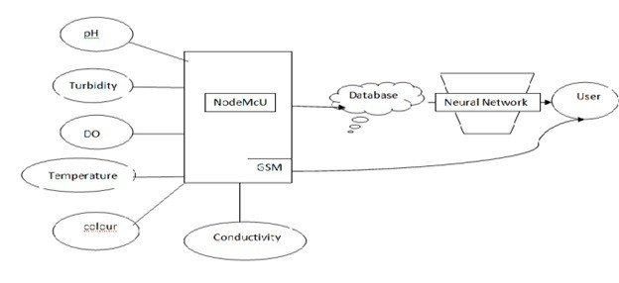

Figure1: SYSTEM ARCHITECTURE

The system architecture is composed of multiple interconnected modules:

* **Sensor Layer:** This includes several water quality sensors such as pH, turbidity, dissolved oxygen (DO), temperature, color, and conductivity. These sensors continuously measure real-time water parameters.
* **NodeMCU:** A microcontroller (ESP8266) that acts as the main processing unit. It collects data from all sensors and formats it for transmission.
* **GSM Module:** Enables wireless data transmission to a remote server or database, especially useful when Wi-Fi is unavailable.
* **Database:** Stores all incoming data for further processing. Data cleaning, preprocessing, and validation are done here before feeding it into the model.
* **Neural Network:** A machine learning model (typically trained with supervised learning techniques) that analyzes the processed data and forecasts water quality status with high accuracy.
* **User Interface:** The final results are delivered to users through a user-friendly platform, allowing for real-time monitoring, alerts, and decision-making.

**3.3 SYSTEM MODULES**

The system modules for the **Water Quality Monitoring and Forecasting System** are carefully designed to enable the collection of real-time water quality data, its transmission, storage, preprocessing, and finally, intelligent forecasting using machine learning algorithms. The project integrates hardware components such as sensors, NodeMCU, and GSM module with a software backend that processes and predicts water quality levels. This modular architecture ensures an efficient and automated pipeline—from sensing environmental parameters to alerting relevant stakeholders based on water quality forecasts. Below are the detailed descriptions of each core module involved in the system:

**3.3.1 Sensor Data Collection**

This module is responsible for collecting real-time water quality parameters using various sensors such as pH, Turbidity, Temperature, and TDS (Total Dissolved Solids). These sensors are interfaced with the NodeMCU microcontroller, which continuously reads environmental parameters. The data collected forms the foundation for analyzing water conditions and predicting the Water Quality Index (WQI). Sensor readings are taken at regular intervals to ensure up-to-date information and continuous monitoring.

**3.3.2 Data Transmission using NodeMCU and GSM**

After collecting data from the sensors, the NodeMCU processes and formats the readings. It then uses a GSM module to send the data to a remote server or cloud database via SMS or the internet, depending on the setup. This module ensures remote water bodies can bemonitored even without Wi-Fi access. It plays a crucial role in establishing a wireless

communication bridge between hardware and software components.

**3.3.3 Data Storage and Management**

This module handles the storage of incoming data into a structured database. The received data is timestamped and organized for easy access and retrieval. The data is essential for training, testing, and evaluating machine learning models. This module ensures that no sensor reading is lost and that the dataset is always up-to-date for future analysis and prediction.

**3.3.4 Data Preprocessing and Feature Engineering**

Raw sensor data is often noisy and inconsistent. This module focuses on data cleaning, handling missing values, normalization, and feature selection. It applies techniques such as univariate, bivariate, and multivariate analysis to extract meaningful insights and reduce dimensionality. [4] The refined dataset is then prepared for input into machine learning models.

**3.3.5 Model Training and Forecasting**

This module uses supervised machine learning algorithms such as Random Forest, Support Vector Machines (SVM), and Gradient Boosting to train models on the historical water quality data. The goal is to forecast the Water Quality Index (WQI) with high accuracy. Various models are compared based on metrics such as accuracy, precision, recall, F1-score, and confusion matrix to select the best-performing algorithm.

**3.3.6 Water Quality Index Prediction and Classification**

Once a model is trained, this module applies it to real-time or new input data to predict the WQI. Based on the output, water quality is classified into categories such as Excellent, Good, Poor, or Contaminated. This information helps identify unsafe water conditions promptly and provides useful insights for environmental monitoring authorities.

**3.4 ALGORITHMS USED**

In this project, various supervised machine learning algorithms are employed to predict the Water Quality Index (WQI) based on the real-time sensor data. Each algorithm is trained and evaluated using performance metrics to identify the most accurate model for water quality forecasting. [5]

**3.4.1 Random Forest Classifier**

The Random Forest algorithm is an ensemble technique that builds multiple decision trees and merges their predictions for improved accuracy and reduced overfitting. It handles large datasets with higher dimensionality and identifies feature importance effectively. [6]

* **WorkingPrinciple**:  
  Random subsets of features and data samples are selected to train each tree. The final classification is determined by majority voting.[7]
* **Mathematics**: Prediction:

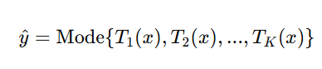

where Tk(x)T_k(x)Tk​(x) is the prediction from the k-th decision tree.



**3.4.2 Long Short-Term Memory (LSTM)**

**Long Short-Term Memory (LSTM)** is a deep learning model designed to predict time-series data by learning long-term dependencies. In your water quality forecasting project, LSTM will help in predicting future water quality values based on past data. [8]

* **Working Principle**: LSTM uses memory cells that store information across time steps, while three gates (forget, input, and output) control the flow of information to learn from historical water quality data.

**Forget Gate**: ft​=σ(Wf​⋅[ht−1​,xt​]+bf​)

**Input Gate**: it​=σ(Wi​⋅[ht−1​,xt​]+bi​)

**Cell State Update**: Ct​=ft​⋅Ct−1​+it​⋅Ct

**Output Gate**: ot​=σ(Wo​⋅[ht−1​,xt​]+bo​)

**Final Prediction**: y^​t​=Wy​⋅ht​+by​

**3.5 SYSTEM MODULES**

**3.5.1 Use case Diagram**

This is a use case in a water quality monitoring and forecasting system that aims to predict the Water Quality Index (WQI) using supervised machine learning. The system involves a sequence of key steps that a user interacts with to ensure accurate forecasting and data-driven water management.

Figure 2: Class Diagram

The first step is Collect Water Quality Data. In this stage, the system gathers raw environmental data from various sources such as the transport traffic department, pollution monitoring units, or IoT-based sensors. These datasets typically include chemical and physical indicators like pH, turbidity, temperature, dissolved oxygen (DO), and biological oxygen demand (BOD), which are essential for water quality assessment.

Next, the user performs Preprocess Data. This includes cleaning the dataset, treating missing or inconsistent values, converting data types if necessary, and preparing the data in a structured format suitable for analysis. Proper preprocessing ensures data reliability and improves model performance.

The third step is Perform Data Analysis, where statistical techniques such as univariate, bivariate, and multivariate analysis are applied. This helps identify trends, patterns, and correlations between variables, offering deeper insights into what influences water quality the most.

Following data analysis, the user proceeds to Train Machine Learning Models. Here, supervised algorithms like Decision Trees, Random Forests, Support Vector Machines (SVM), and K-Nearest Neighbors (KNN) are used. These models learn from the historical data and develop the ability to predict WQI levels based on input features.

Once the models are trained, the system moves to Evaluate Models. Each model is tested using metrics such as accuracy, precision, recall, F1-score, and confusion matrix. This evaluation ensures that the most accurate and reliable model is selected for practical use.

The final step is Classify and Prioritize WQI. In this stage, the model’s output is categorized into water quality classes like Excellent, Good, Moderate, Poor, and Very Poor. This classification supports authorities in making timely decisions, focusing efforts on critical zones, and enforcing pollution control measures.

**3.5.2 Class Diagram**

This is a use case in a water quality monitoring and forecasting system that models the User class through a UML class diagram. The User class represents individuals who interact with the system, such as environmental analysts or technical users.

It contains essential user-related attributes including username, password, email, mobile no, and adress, which are required for identification, authentication, and communication within the system.



Figure 3: Class Diagram

In addition to the attributes, the class defines several operations that the user can perform. These include register() and login() functions for creating and accessing user accounts securely. Once authenticated, the user can invoke load preprocess dataset() to import and clean the water quality data, which is a critical step before model training. The class also supports executing machine learning models through methods like run LSTM algorithm() and run random forest algorithm(), enabling the user to train models on time-series and tabular data respectively. After the models are trained, the forecast water quality() method is used to generate predictions based on the Water Quality Index (WQI). Finally, the logout() function allows the user to safely terminate their session. This class encapsulates the core functionalities required for user-driven interaction with the forecasting system, supporting both machine learning operations and secure access.

**3.5.3 Sequence Diagram**

This is a use case in a water quality monitoring and forecasting system, illustrated through a UML sequence diagram that shows the step-by-step interaction between a User and the Application. The diagram represents the flow of operations for forecasting water quality using machine learning techniques.

The sequence begins when the user initiates a login request to the application. Upon successful authentication, the user proceeds to load and preprocess the dataset, which involves cleaning, normalizing, and preparing the raw water quality data for analysis. This is a crucial step to ensure the machine learning models receive high-quality input.

Following data preparation, the user can choose to run the LSTM algorithm, a deep learning model suitable for time-series prediction. This model helps capture sequential patterns in water quality data.

Alternatively, or additionally, the user may run the Random Forest algorithm, a powerful ensemble learning method used for classification and regression tasks, offering high accuracy and interpretability.



Figure 4: Sequence Diagram

.

After model execution, the user performs the forecast water quality operation, where the trained model generates predictions about the Water Quality Index (WQI). These predictions are then used to classify water quality levels and assist in environmental decision-making.

Finally, the user sends a logout request to terminate the session securely. The diagram effectively captures the linear and interactive nature of operations between the user and the system, demonstrating how machine learning techniques are integrated into the application for real-time water quality monitoring and forecasting**.**

**3.5.4 Collabration Diagram**

This is a use case in a water quality monitoring and forecasting system, depicted through a UML communication diagram that shows the structured message flow between the User and the Application. This diagram captures the sequence of operations required for machine learning-based forecasting of water quality**.**



Figure 5: Collabration Diagram

The interaction begins when the user logs in to the system (message 1), establishing authentication and access to the application. Once logged in, the user sends a command to load and preprocess the dataset (message 2). This step is essential for cleaning the data, handling missing values, and transforming it into a suitable format for model training.

Next, the user triggers the execution of the LSTM algorithm (message 3), which is particularly useful for time-series prediction and modeling trends in water quality data over time. Following this, the user may also choose to run the Random Forest algorithm (message 4), a robust ensemble learning technique used for classification and regression.

After model execution, the system proceeds to forecast the water quality (message 5), generating predictions that classify water conditions based on the Water Quality Index (WQI). These results aid in identifying pollution levels and making informed environmental decisions.Finally, the user performs a logout operation (message 6), ending the session and ensuring secure closure of the system. This communication diagram effectively illustrates the message sequence and interaction path in the system, highlighting how each user command leads to specific machine learning-driven actions within the application.

**CHAPTER 4**

**RESULT AND ANALYSIS**

To run project first copy content from ‘DB.txt’ file and then paste in MYSQL database to create it and now double click on ‘run.bat’ file to start DJANGO server and then will get below output

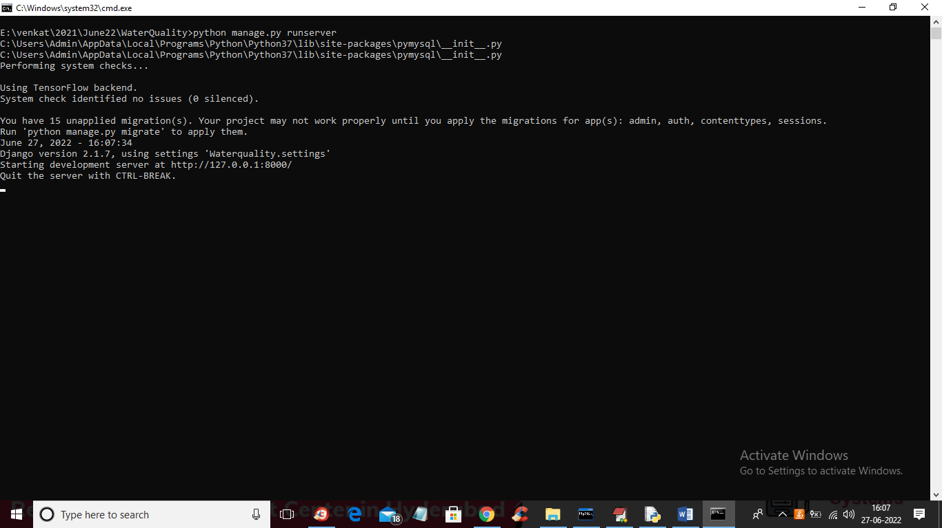

Figure 6: Django Development Server Startup

In above screen DJANGO server started and now open browser and enter URL as ‘http://127.0.0.1:8000/index.html’ and press enter key to get below page

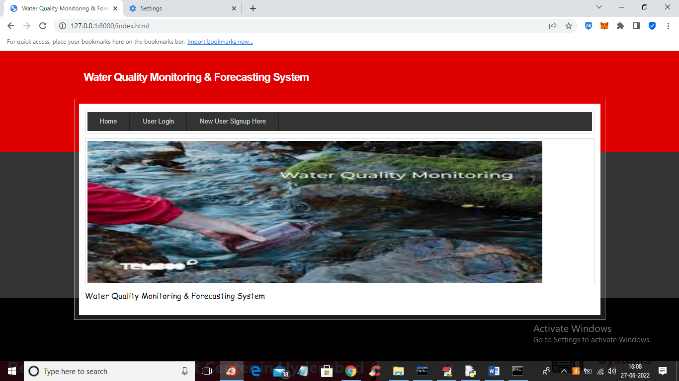

Figure 7: Home Page of Water Quality Monitoring & Forecasting System

In above screen click on ‘New User Signup Here’ link to get below screen

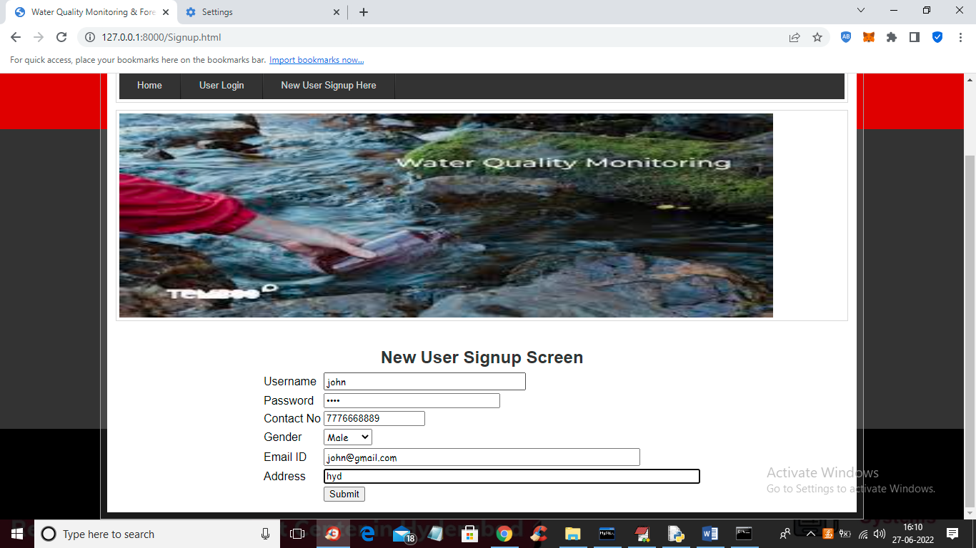

Figure 8: New User signup screen

In above screen user is signing up and then press button to get below screen



Figure 9: User Registration Completion Screen

In above screen signup process completed and now click on ‘User Login’ link to get below screen

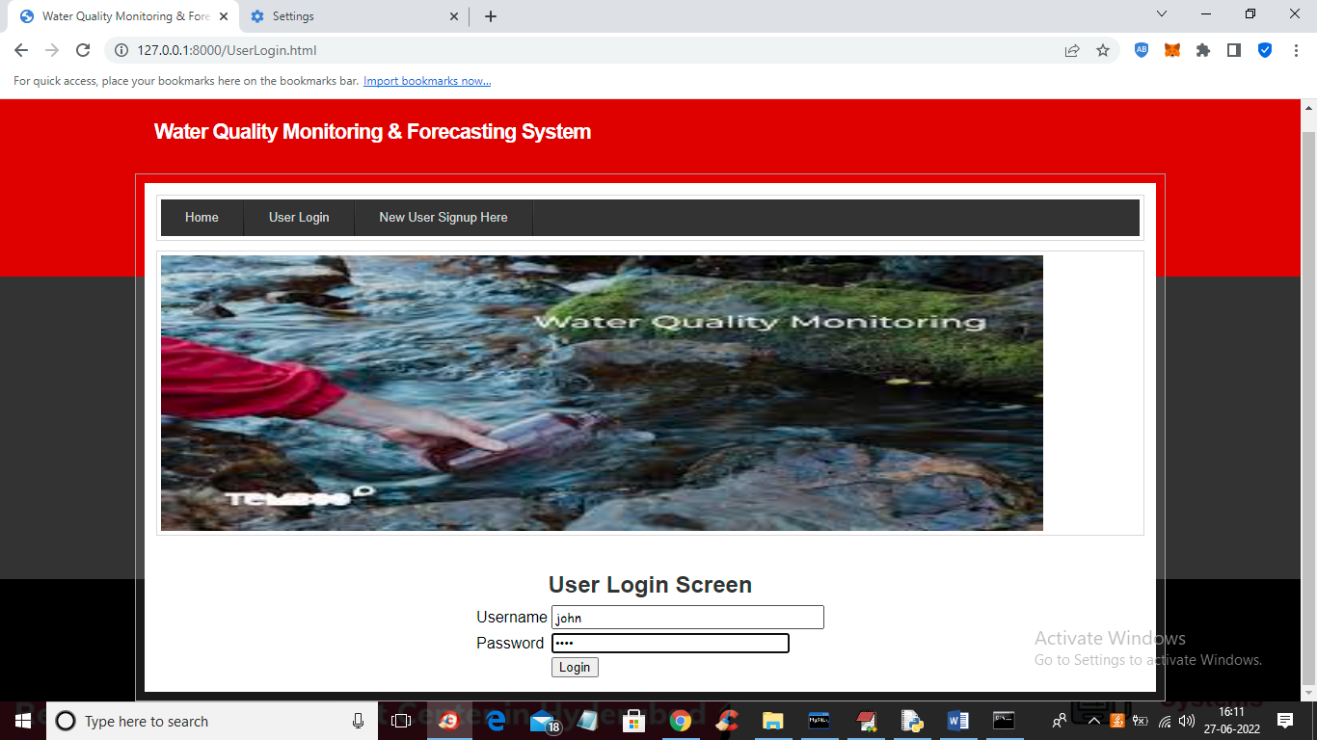

Figure 10: User Login Screen

# In above screen user is login and after login will get below screen

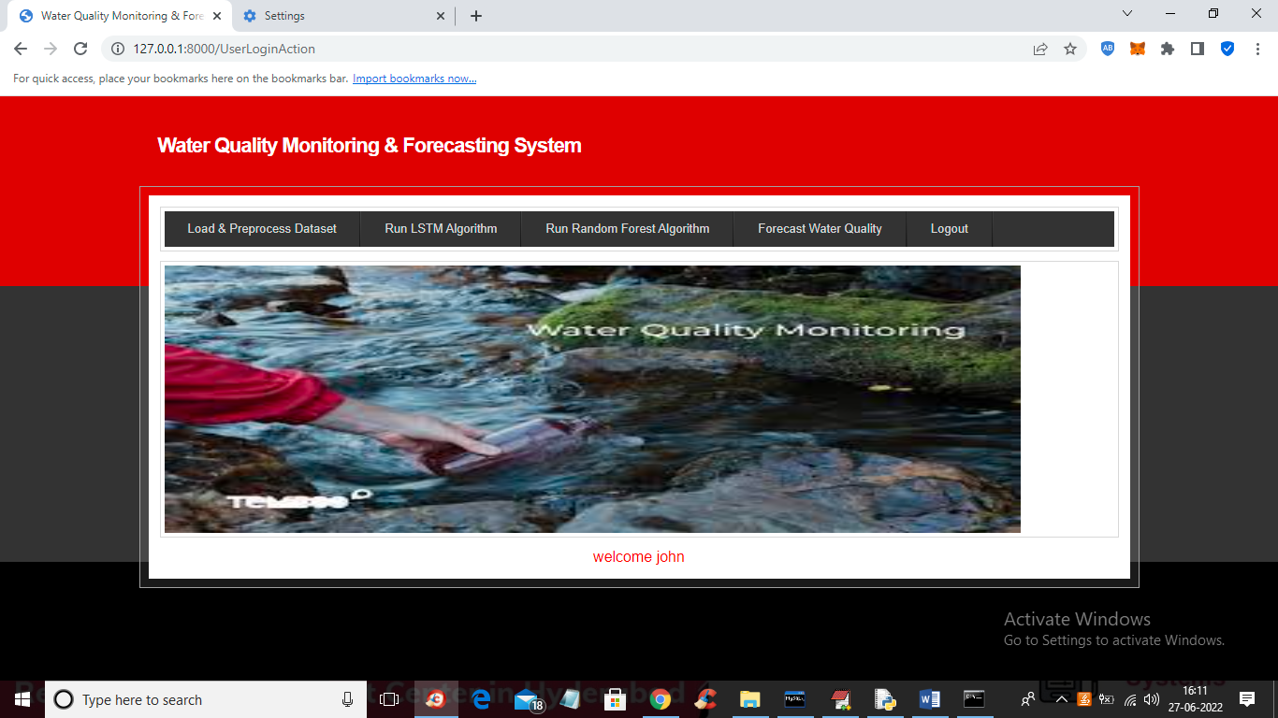

Figure 11: User Dashboard – Water Quality Monitoring & Forecasting System

In above screen click on ‘Load & Preprocess Dataset’ link to load and process dataset such as replacing missing values with 0 and then split dataset into train and test and get below output

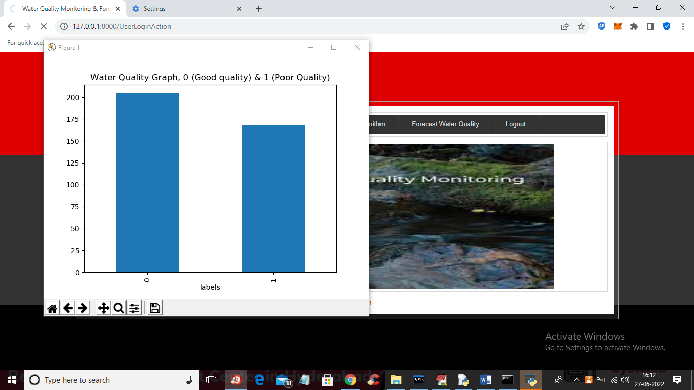

Figure 12: Water Quality Classification Graph

In above screen dataset is processed and in above graph x-axis contains water quality as 0 or 1 where 0 means GOOD quality and 1 means POOR quality and y-axis represents number of records and now close above graph to get below screen

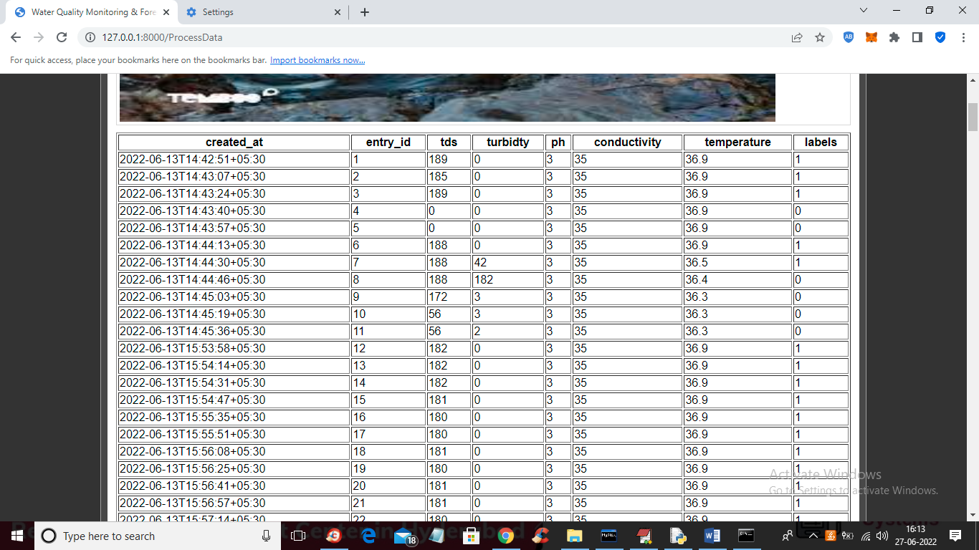

Figure 13: Processed Water Quality Dataset View

In above screen we can see dataset processed and loaded and now click on ‘Train LSTM Algorithm’ link to train LSTM and get below output

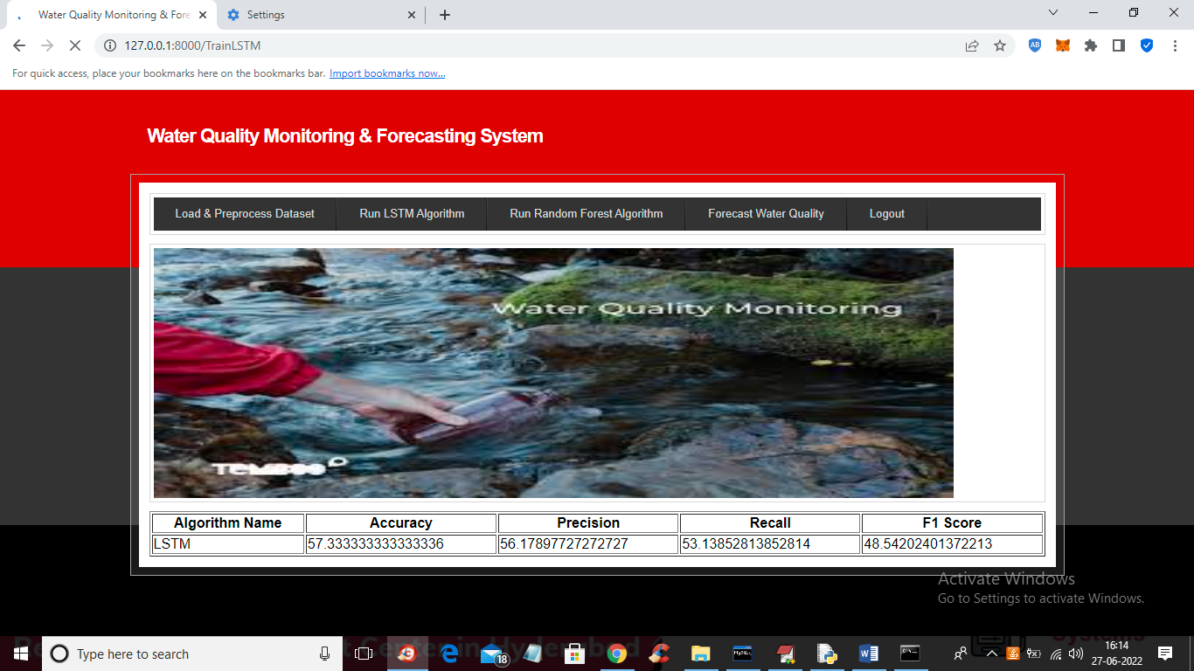

Figure 14: Results of LSTM Algorithm

In above screen LSTM got trained and with LSTM we got 57% accuracy and now click on ‘Train Random Forest Algorithm’ link to train Random Forest and get below output

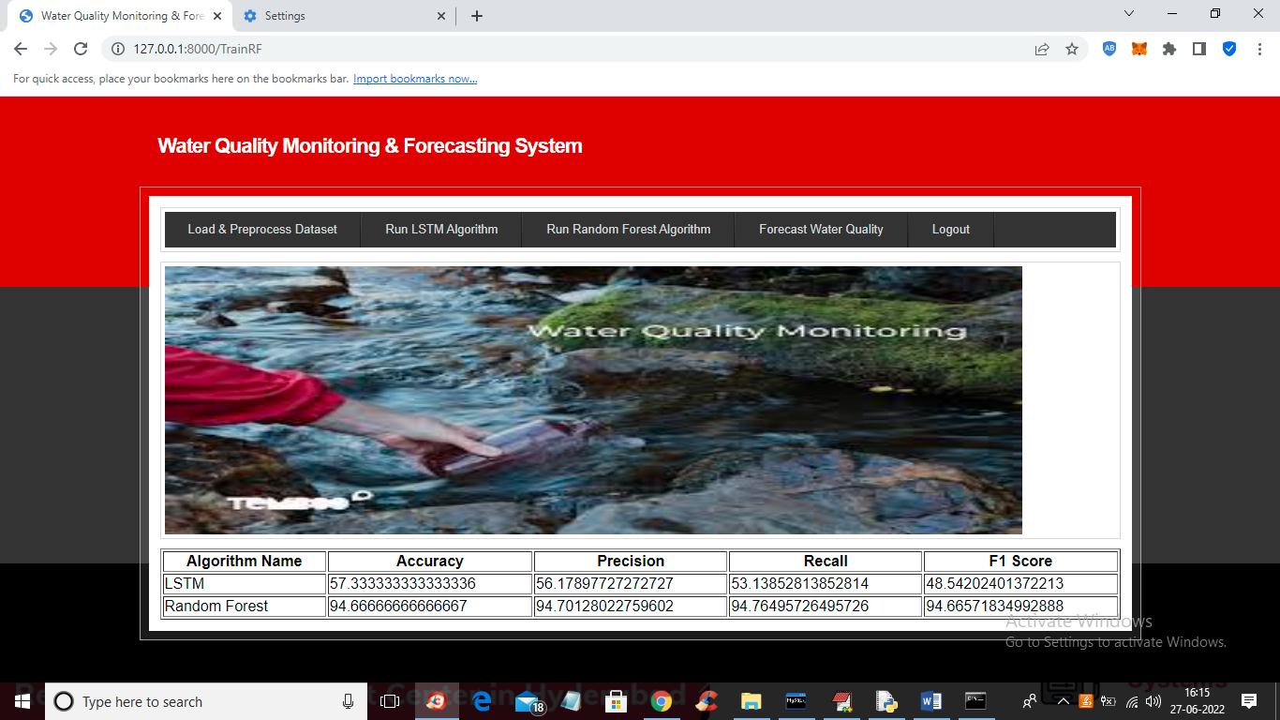

Figure 15: Results of Random Forest Algorithm

In above screen with Random Forest we got 94% accuracy and now click on ‘Forecast Water Quality’ link to upload test data and then forecast quality

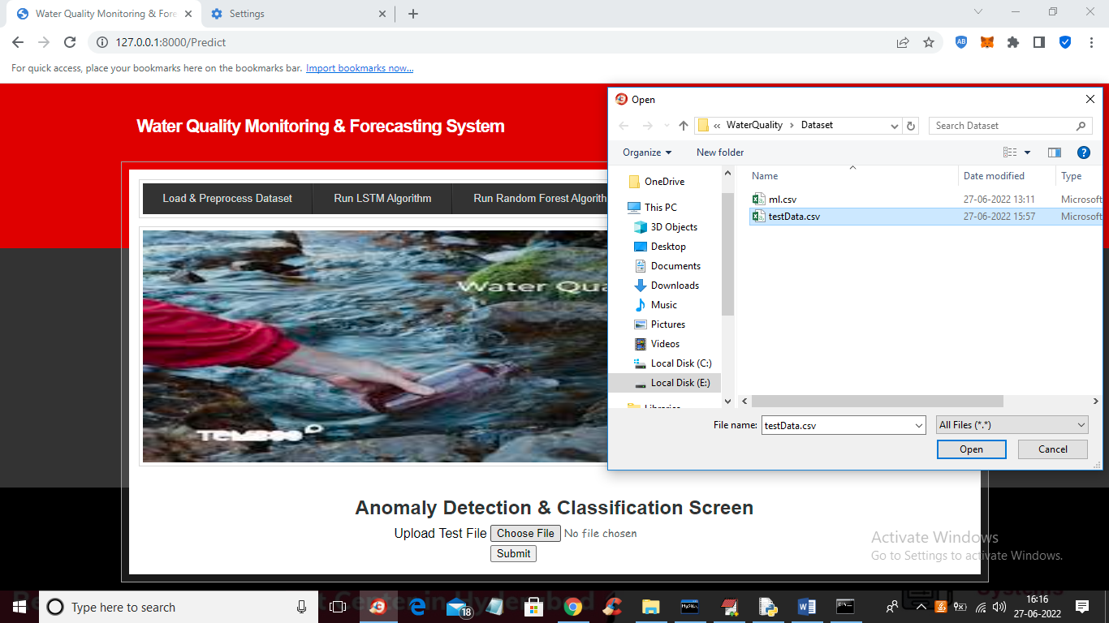

Figure 16: Test Data Upload Screen for Anomaly Detection and Classification

# In above screen selecting and uploading ‘testData.csv’ file and then click on ‘Open’ and ‘Submit’ button to get below forecast output

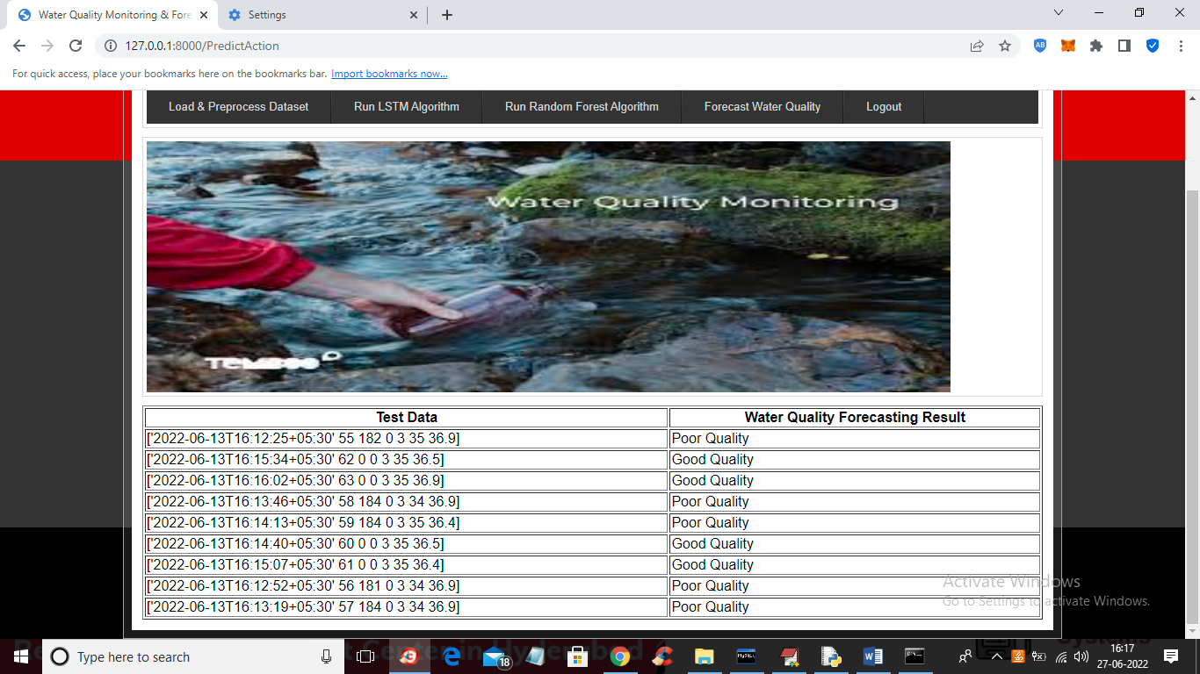

Figure 17: Water Quality Forecasting Results Displayed after Model Prediction

In above screen in tabular output first column contains water test values and second column contains forecast result as ‘Poor’ or “Good”

# 

# **CHAPTER 5**

# **CONCLUSION**

The Water Quality Monitoring and Forecasting System successfully leverages the power of machine learning to tackle the pressing issue of water pollution. By integrating supervised learning algorithms such as Random Forest and LSTM, the system efficiently handles complex environmental data to predict the Water Quality Index (WQI). A comprehensive analytical pipeline involving data cleaning, missing value handling, exploratory data analysis, and model evaluation ensures accurate and meaningful insights. Among the models tested, the Random Forest classifier achieved the highest accuracy of 94%, proving its reliability and robustness for classifying water samples into categories like *Good*, *Moderate*, or *Polluted*.

Furthermore, the system incorporates real-time data acquisition through sensors measuring vital parameters such as pH, turbidity, temperature, conductivity, and TDS. These measurements, when analyzed, provide valuable indicators of water quality. The integration of this analytical engine into a user-friendly Django web application allows for seamless data upload, model training, and result visualization. The platform not only forecasts water quality but also recommends suitable purification methods, such as boiling, UV filtration, or RO systems, ensuring practical usability for everyday decision-making.

The solution is built on a modular and scalable architecture, combining the capabilities of IoT, cloud computing, and AI-powered analytics. This flexibility allows the system to be deployed across diverse geographic and climatic regions, making it a scalable solution for urban, rural, and remote water monitoring scenarios. Additionally, the system supports environmental agencies and policy-makers with actionable insights that can guide resource allocation, contamination control, and public health initiatives. Its minimal dependency on manual intervention ensures efficiency, accuracy, and timely response to emerging water quality issues.

In conclusion, this project exemplifies the synergy between technology and environmental sustainability. It demonstrates how machine learning can be used not just for prediction, but for prevention and proactive decision-making. The Water Quality

Monitoring and Forecasting System stands as a promising tool for smart water management, offering a practical approach to ensuring clean and safe water resources. With continued development, it has the potential to evolve into a nationwide or even global platform, supporting the Sustainable Development Goals (SDG-6: Clean Water and Sanitation) and promoting a healthier, more informed society.

Future Directions

The future of water quality monitoring and forecasting lies in the integration of advanced technologies and broader data ecosystems to create smarter, more proactive environmental management systems. The proposed system already showcases the power of machine learning and IoT in improving public health and environmental safety. However, several promising directions for enhancement could further elevate the system’s accuracy, usability, and real-world impact.

Integration of Real-Time Sensor Networks

Future implementations could focus on the deployment of real-time water quality sensor networks across rivers, lakes, and reservoirs. This would enable continuous data streaming into the system, eliminating the need for manual sampling and data upload. Real-time monitoring ensures immediate alerts on sudden contamination events, which is crucial for disaster response and resource management.

Use of Advanced Deep Learning Techniques

In addition to traditional machine learning models, the system can be enhanced using more sophisticated algorithms like Convolutional Neural Networks (CNNs) for spatial data and Transformer-based architectures for complex time-series analysis. These models can improve prediction performance, especially when integrated with geospatial and weather-related data sources.

Integration with Geographic Information Systems (GIS)

Combining water quality predictions with GIS mapping can offer a spatial perspective on contamination risks. This would allow authorities to visualize pollution hotspots on interactive maps and prioritize regions for treatment or inspection. GIS

integration would also support data layering with population density, industrial zones, and rainfall patterns for deeper insights.

Automated Purification Response Systems

The system could evolve to not only detect and predict pollution but also automatically trigger purification mechanisms. For instance, smart valves could redirect contaminated water away from municipal lines or activate in-line filtration systems. This would create a fully autonomous water quality management loop, significantly reducing human dependency.

User-Focused Mobile and Alert Systems

Developing a mobile-friendly application with real-time alert features can empower communities to monitor their local water sources. Push notifications based on forecasted quality or sudden changes would help users avoid using unsafe water and promote greater community awareness and participation.

Cloud and Edge-Based Data Processing

To scale the system for widespread deployment, especially in remote areas, the future system could utilize edge computing for local data processing and cloud services for centralized analytics and storage. This hybrid approach ensures both speed and scalability while reducing data transfer costs and latency.

Cross-Disciplinary Data Fusion

Finally, integrating data from meteorological systems, agricultural runoff reports, industrial discharge logs, and public health records would enable the system to make context-aware predictions. Such holistic models can forecast not only water quality but also potential outbreaks of waterborne diseases, making the system a vital part of public health infrastructure.

**REFERENCES**

[1] World Health Organization, *Guidelines for Drinking-water Quality*, 4th ed., Geneva, Switzerland: WHO Press, 2017.

[2] B. J. Hao Cen, K. Koedinger, and Carnegie, "Learning Factors Analysis – A General Method for Cognitive Model Evaluation and Improvement," in *Proc. Int. Conf. Intelligent Tutoring Systems*, vol. 8, pp. 164–175, 2006.

[3] A. Gholami, A. H. Yari, S. Hashemipour, and M. M. Aliabadi, "A comprehensive review of deep learning for water quality monitoring," *Environmental Monitoring and Assessment*, vol. 192, Art. no. 167, 2020.

[4] C. Yun, D. Shin, H. Jo, J. Yang, and S. Kim, "An Experimental Study on Feature Subset Selection Methods," in *Proc. 7th IEEE Int. Conf. Comput. Inf. Technol. (CIT)*, pp. 77–82, 2007.

[5] G. Chandrashekar and F. Sahin, "A survey on feature selection methods," *Computers & Electrical Engineering*, vol. 40, no. 1, pp. 16–28, 2014.

[6] M. Pal, "Random forest classifier for remote sensing classification," *International Journal of Remote Sensing*, vol. 26, no. 1, pp. 217–222, 2005.

[7] J. S. Ham, Y. Chen, M. M. Crawford, and J. Ghosh, "Investigation of the random forest framework for classification of hyperspectral data," *IEEE Transactions on Geoscience and Remote Sensing*, vol. 43, no. 3, pp. 492–501, 2005.

[8] B. J. Hao Cen, K. Koedinger, and Carnegie, "Learning Factors Analysis – A General Method for Cognitive Model Evaluation and Improvement," in *Proc. Int. Conf. Intelligent Tutoring Systems*, vol. 8, pp. 164–175, 2006. *(Duplicate of [2]; consider removing or merging)*